Software development: Mandarin group

Introduction
This documentation describes the structure and design of the BioInformatics Mandarin Software developed during the BioInformatics Software group project course 2017-18 at Queen Mary University, London (U.K.). The Mandarin software was developed to allow analysis of RNA or DNA data in FASTA format. The software allows a BLAST search of the data input from the user, and statitistical analysis with R-packages producing different types of graphical analyses such as Volcano plot, dendogram, and Heatmaps, and tables.
The aim of the documents is to describe the structure and design of the Mandarin Sowftware in the way that create interest, and concerns of future stakeholders. We understand stakeholders as:
- Users and customer that need to be assure that the structure will provide system functionability, and also include non-functional requirements such as reliability, and future upgrades.
- Developers that desire a simple and efficient system to minimize the complexity, and development effort.
- Maintenance Programmers that will like to be assure that the programs is easy to update and maintain in the future.

Development of the Mandarin Software

Flask
In order to develop this software the Mandarin group have used Flask. What is Flask? Flask is defined as a microframework that uses the Python computer language. It was developed by Armin Ronacher. Flask is based on the Werkzeug toolkit, and Jinja2 template engine. The routing, debugging and Web Server Gateway Interface (WSGI) are provide by Werkzeug and the template support comes from Jinja2. Figure 1 shows a basic Flask structure.

From flask import Flask
app=Flask(__name__)
@app.route(‘/’)
def index():
return ‘X’
if __name__==’__main’:
app.run(debug=True)

Figure 1. Showing the main feature of a Flask based website.
This first statement of the structure creates an application instance, which is an object of class Flask. This imports the Flask library and creates a new website in the variable ‘app’ (Figure 2). The second statement of the application is the route and view function. Through the route function the application knows the code required to run each URL request. Flask does this by mapping the URLs to the Python function The Python def index() is called a view function, and works as a handler for the application root URL, the return value of this function is called the response, and that is what will the user will see (Figure 3).

from flask import Flask
app=Flask(__name__)

Figure 2. Show the first statement of a Flask based website.
@app.route(‘/’)
def index():
return<h1>X<h1>

Figure 3. A simple representation of the app.route decorator, which register the decorated function as a route. It can has as many decorators as the website requires.

The last statement of a Flask based website is the server startup. The first line of the statement ensure that the application runs when the scripts is executed directly. During the development of a website it is advisable to enable the debug mode, which activates the debugger, and reloader (Figure 4).
if __name__==’__main__’:
app.run(debug=True)

Figure 4. Showing the last statement of the Flask based website that will initiate the application.

Basic webpage: Dreamweaver

HyperText Mark-up Language (HTML) & Cascading Style Sheets (CSS)

Creating a basic web page involves a few steps including start with the content, give structure to the document, identify text elements, add images, change the style and formatting as this requires the use of HTML attributes.
In the development of the Mandarin software HTML documents were written and edited using both Adobe Dreamweaver CC and standard text editor. Adobe Dreamweaver CC is unique and flexible coding engine for creating user-friendly web-interface implementing some modern features such as CSS. It is used from front end developers and designers across the world to manage websites. What makes it unique and easy to use is its visual aids, auto-indentation, code coloring and resizable fonts that reduce errors and make the code readable.

The HTML pages are surrounded by <html> tags, two main sections< head> and <body> contain the meta data, title, links to external resources such as Cascading Style Sheets (CSS) and JavaScript files. The <!DOCTYPE html> on the top is recognized by the browser of how the web page is formatted. See Appendix 1 for full explanation of the different tags.

CSS describes the style of an HTML document. The syntax of CSS is quite simple and is contained with the <head> section of an HTML document. The web browser will use this information when opening an HTML document. The CSS code is contained within the <style> tags and is made up of a list of declarations. To see full description go to Appendix 2.

Java Scripts

Some input

Web standards and compatibility

An HTML document could be created both correctly and incorrectly. Web browsers have the ability to deal with small mistakes and cover errors in the HTML code, therefore it is important to follow the HTML standards correctly and test the page on different browsers. World Wide Web Consortium (W3C) offers validation service that allows checking whether or not the created HTML page follows the standards. This service can be found at validator.w3.org it gives the user to validate the file by URL checking, uploading the file or pasting some of the HTML code

Software Description, and Functionality

The software developed for this tasks is folder structure according to figure 5. All these are sub-folders within the FlaskApp folder. The main folder, FlaskApp, contains the python codes to run this application, and analyse data.

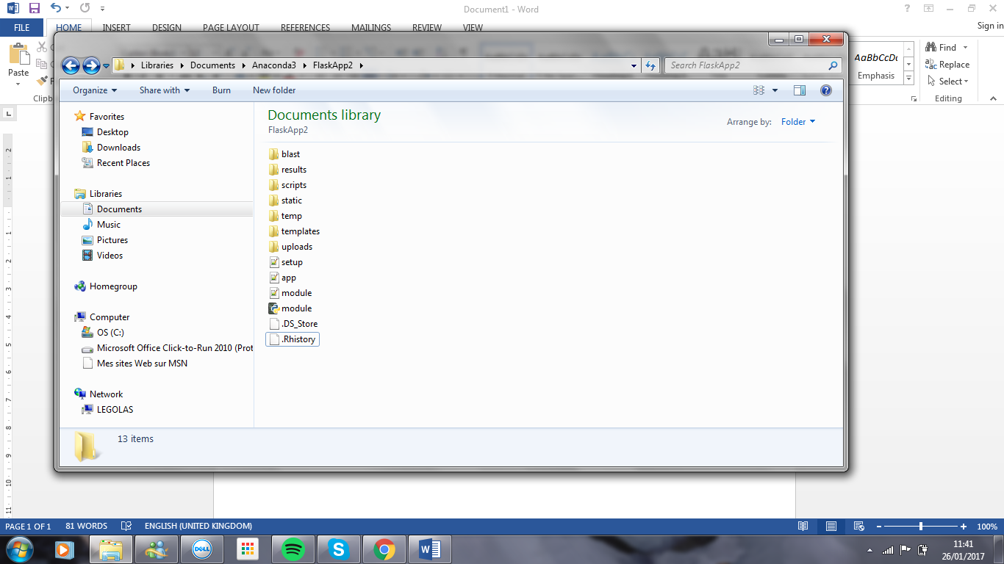
Figure 5. Showing the principal structure of the “ ”. Showing the 7 main folders, and python files needed to run the software.

Description of sub-folders

- Blast sub-folder; this folder stores the blast generate FASTA files.
- Results sub-folder; this folder stores the tables obtained from the R-analysis..
- Scripts sub-folder;
- Static sub-folder; this folder stores static files such as background pictures, and graphs obtained from R plots such as Volcano, Heatmap, and dendogram.
- Temp sub-folder; this folder holds temporary files containing information while a new file is being made.
- Template sub-folder; this folder store templates such as html files.
- Upload sub-folder;

How the Mandarin software works

The application is run through the app.py file. This file consist of 6 function:
- def allow_file(filename); checks if the file to be uploaded are of the allow type.
- def main(); this send a Ajax request. Ajax is a client-side script that communicates to and from a server/database without the need for a postback or a complete page refresh.
- def choose(); this communicate with the upload.htm, and allow to select the file to be uploaded.
- def upload(); this function has different functionalities such as:
  - checking if the selected files belong to the file extension allowed
  - make files safe, and remover unsupported chars
  - move files from the temp folder to the upload folder
  - save files into a list, redirect the user to uploaded file
  - redirect the user to the uploaded_file route showing the the files on the browser
  - load a htm page with a ling to each uploaded file
- def analyse(); will direct the files to a blast search, and R-analysis.
- def uploaded_file

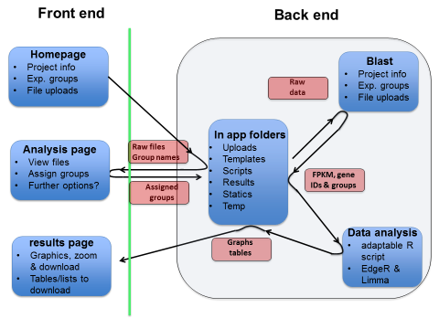

Appendix 1. HMTL tags and formatting
- Commonly used <head> tags:
<title> Defines the title of the webpage.
<meta> Defines any metadata used to specify page description.
<style> Defines the style of the webpage in accordance with CSS stylesheet.
<link> Links with external resources.
<script> Introduces JavaScript code or link to external JavaScript file.
- Commonly used <body> tags:
<a> Links with different pages within the website but also to other external websites.
<br /> Defines a line break.
<div> Defines a section.
<footer> Defines copyright information.
<form> Defines user input such as test field and many more.
<h1> to <h6> Defines a number of heading level.
<header> Defines container with introductory content.
<img /> Introduces images to the webpages, src indicates filenames and its position and alt indicates the name of the image.
<input> Defines a field that allows the user to enter data.
<ol> Defines a ‘list term’ <li>
<p> Defines a paragraph of text.
<select> Defines a list of options <option>
<strong> Defines important text.
<tbody> Defines a table.
<td> Defines a normal table column.
<! -- -- > Add comments.

Appendix 2. CSS tag and formatting
- body:
- font- family-specifies the font for an element.
- background-image-sets background image for an element.
- background-size- specify the size of the image.
- background color-sets the background color.
- loading:
- position-specify the type of positioning method.
- top-sets the top position in percent.
- left-sets the left position in percent.
- loading bar:
- display- displays an inline-block element.
- width- sets the width of an element.
- height- sets the height of an element.
- border-radius- adds rounded corners.
- animation- specify a name for a few properties.
- loading-bar nth-child:
- background-color- sets the background color.
- animation delay- specify a delay for the start of an animation.
- keyframes loading:
- transform- allows to scale elements.

